PART F

Case 1.

External pressure coefficients, $C_{p,e}$
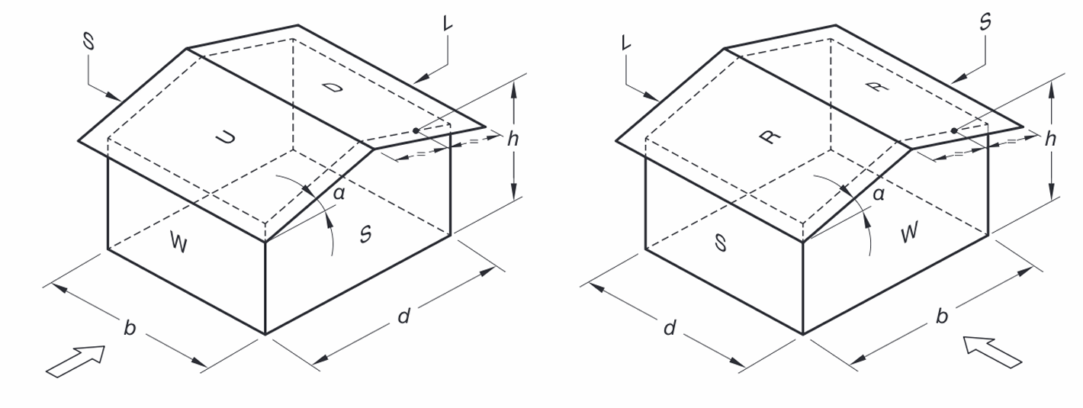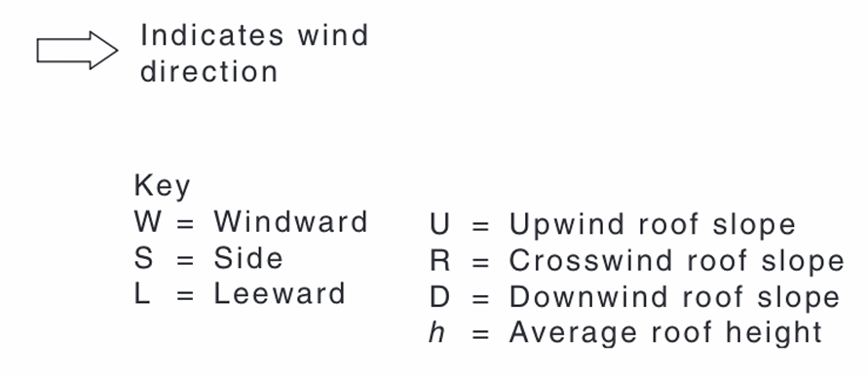
$$L_{R}=\frac{L_{p}}{L_{m}}=100⟹L_{p}=100L_{m}$$
In the model:
$$b_{m}=105 mm⟹b_{p}=10.5 m$$
$$d_{m}=48 mm⟹d_{p}=4.8 m$$
$$h_{m}=37+\frac{53-37}{2}=45 mm⟹h_{p}=4.5 m$$
Roof pitch: $α=\tan^{-1}\left(\frac{1.6}{2.4}\right)=33.69°$
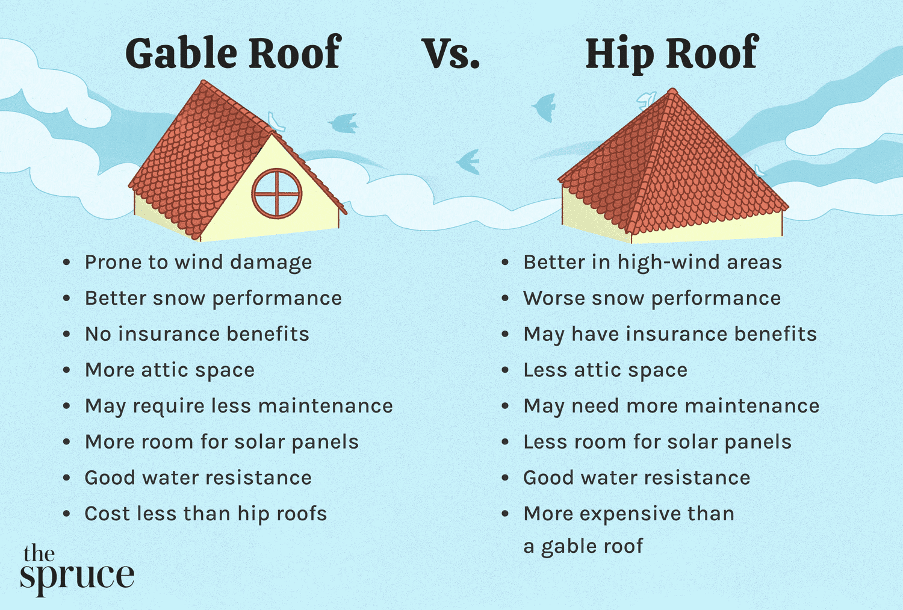
Wall type | $$C_{p,e}$$ | Reference
Windward wall (W) | $$0.7$$ | Table 5.2(A)
Leeward wall (L) | $$-0.5$$ | Table 5.2(B), $θ=0°$  Roof pitch $α=33.69°>25°$  $$\frac{d}{b}=\frac{4.8}{10.5}=0.4571>0.3$$
Sidewalls (S) | Horizontal distance from windward edge between 0 and 4.5m.  $$C_{p,e}=-0.65$$ | Table 5.2(C)  When the horizontal distance from windward edge is between 0 and 4.5m, the distance is considered as 0 to 1h. When the distance is between 4.5m and 4.8m, the distance is between 1h and 2h.
Horizontal distance from windward edge between 4.5m and 4.8m.
$$C_{p,e}=-0.5$$
Upwind slope (U) | $$-0.2230, 0.2863$$ | Table 5.3(B)  Roof pitch $α=33.69°>10°$  $$\frac{h_{p}}{d_{p}}=\frac{4.5}{4.8}=0.9375$$  Linear interpolation on $α$ and $h/d$.
Downwind slope (D) | $$-0.6$$ | Table 5.3(C)  Roof pitch $α=33.69°>25°$  $$\frac{b_{p}}{d_{p}}=\frac{10.5}{4.8}=2.1875<3$$

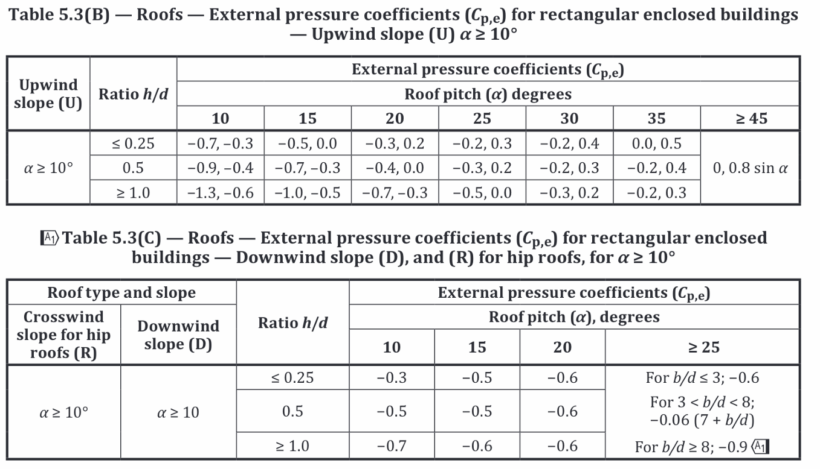

Aerodynamic shape factor, $C_{shp}$
Only need to consider frictional drag forces and external pressures for enclosed buildings.
[Cl 5.2(a)]
External pressure: $C_{shp}=C_{p,e}K_{a}K_{c,e}K_{l}K_{p}$
Frictional drag forces: $C_{shp}=C_{f}K_{a}K_{c,e}$ (Not considered, see page 5)

External pressure
$C_{p,e}$ already found
$K_{a}$ can be found by Table 5.4. with Tributary area $A<1 m^{2}$
 | Roofs (U, D) and side walls (S) | Windward walls (W) $\left(h_{p}<25 m\right)$ | Leeward walls (L) $\left(h<25 m\right)$
$$K_{a}$$ | $$1.0$$ | $$1.0$$ | $$1.0$$

$K_{c,e}=0.8$ (Table 5.5, Design case (a))

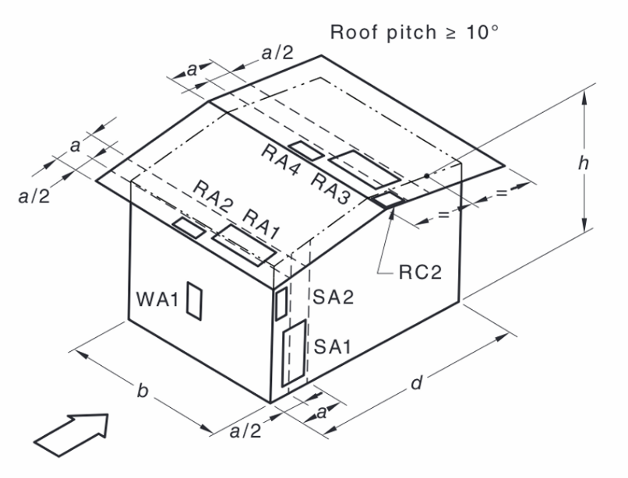
Local pressure factor $K_{l}$ for cladding [Cl 5.4.4]
The value of dimension $a$,
Walls: $a=\min\left(0.2b,0.2d,h\right)$
Roofs:
- $\frac{h_{p}}{b_{p}}$ or $\frac{h_{p}}{d_{p}}≥0.2$, $a=\min\left(0.2b,0.2d\right)$
- Both $\frac{h_{p}}{b_{p}}$ and $\frac{h_{p}}{d_{p}}<0.2$, $a=2h$.

Walls:
$$a=\min\left(0.2b_{p},0.2d_{p},h_{p}\right)=\min\left(0.2×10.5,0.2×4.8,4.5\right)=0.96$$
$$a^{2}=0.9216$$
$$0.25a^{2}=0.2304$$
Roofs:
$$\frac{h_{p}}{b_{p}}=\frac{4.5}{10.5}=0.4286>0.2$$
$$a=\min\left(0.2b_{p},0.2d_{p}\right)=0.96$$
The context only mentioned “tributary area of each fixing is less than 1 m2 in full scale”. We consider the worst-case scenario here, which is $A≤0.25a^{2}$.
Design case | Reference case | Location (Proximity to edge) | $$K_{l}$$
Windward wall (W) | WA1 | Anywhere | $$1.5$$
Downwind corners of roofs with pitch $≥10°$ | RC2 | < 0.96m from both roof edge and ridge | $$3.0$$
Upwind roof edges | RA1 | < 0.96m | $$1.5$$
 | RA2 | < 0.48m | $$2.0$$
Downwind side of hips and ridges of roofs with pitch $≥10°$ | RA3 | < 0.96m | $$1.5$$
 | RA4 | < 0.48m | $$2.0$$
Sidewall near windward wall edges | SA1 | < 0.96m | $$1.5$$
 | SA2 | < 0.48m | $$2.0$$
All other areas | - | - | $$1.0$$

Permeable cladding reduction factor, $K_{p}$ [Cl 5.4.5]
We have solid cladding, $K_{p}=1.0$

Frictional drag forces [Cl 5.5]
$$\frac{d_{p}}{h_{p}}=\frac{4.8}{4.5}=1.067<4$$
$$\frac{d_{p}}{b_{p}}=\frac{4.8}{10.5}=0.4571<4$$
No need to consider frictional drag forces hence neither $\frac{d}{h}$ nor $\frac{d}{b}$ is greater than 4.

Case 2.

External pressure coefficients, $C_{p,e}$
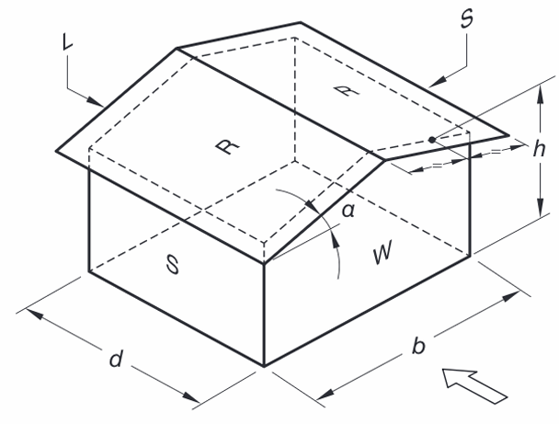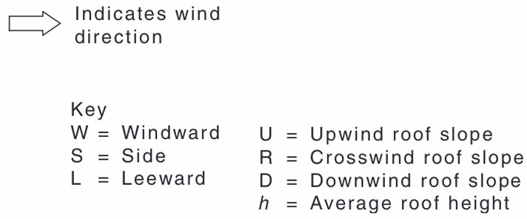
$$d_{p}=10.5 m$$
$$b_{p}=4.8 m$$
$$h_{p}=4.5 m$$
Roof pitch: $α=\tan^{-1}\left(\frac{1.6}{2.4}\right)=33.69°$
Wall type | $$C_{p,e}$$ | Reference
Windward wall (W) | $$0.7$$ | Table 5.2(A)
Leeward wall (L) | $$-0.29$$ | Table 5.2(B), $θ=90°$  Roof pitch $α=33.69°>25°$  $$\frac{d}{b}=\frac{10.5}{4.8}=2.1875$$  Linear interpolation:  $$-0.3+\frac{2.1875-2}{4-2}\left(-0.2-\left(-0.3\right)\right)=-0.290625$$
Sidewalls (S) | Horizontal distance from windward edge between 0 and 4.5m.  $$C_{p,e}=-0.65$$ | Table 5.2(C)  When the horizontal distance from windward edge is between 0 and 4.5m, the distance is considered as 0 to 1h. When the distance is between 4.5m and 9m, the distance is between 1h and 2h. Between 9m and 10.5m is in the range of 2h to 3h.
Horizontal distance from windward edge between 4.5m and 9m.
$$C_{p,e}=-0.5$$
Horizontal distance from windward edge between 9m and 10.5m.
$$C_{p,e}=-0.3$$
Upwind slope (U) | $$-0.1578, 0.4024$$ | Table 5.3(B)  Roof pitch $α=33.69°>10°$  $$\frac{h_{p}}{d_{p}}=\frac{4.5}{10.5}=0.4286$$  Linear interpolation on $α$ and $h/d$.
Downwind slope (D) | $$-0.6$$ | Table 5.3(C)  Roof pitch $α=33.69°>25°$  $$\frac{b_{p}}{d_{p}}=\frac{4.8}{10.5}=0.4571<3$$

Aerodynamic shape factor, $C_{shp}$
Only need to consider frictional drag forces and external pressures for enclosed buildings.
[Cl 5.2(a)]
External pressure: $C_{shp}=C_{p,e}K_{a}K_{c,e}K_{l}K_{p}$
Frictional drag forces: $C_{shp}=C_{f}K_{a}K_{c,e}$ (Not considered, see page 7)

External pressure
$C_{p,e}$ already found
$K_{a}$ can be found by Table 5.4. with Tributary area $A<1 m^{2}$
 | Roofs (U, D) and side walls (S) | Windward walls (W) $\left(h_{p}<25 m\right)$ | Leeward walls (L) $\left(h<25 m\right)$
$$K_{a}$$ | $$1.0$$ | $$1.0$$ | $$1.0$$

$K_{c,e}=0.8$ (Table 5.5, Design case (a))

Local pressure factor $K_{l}$ for cladding [Cl 5.4.4]
Walls:
$$a=\min\left(0.2b_{p},0.2d_{p},h_{p}\right)=\min\left(0.2×10.5,0.2×4.8,4.5\right)=0.96$$
$$a^{2}=0.9216$$
$$0.25a^{2}=0.2304$$
Roofs:
$$\frac{h_{p}}{b_{p}}=\frac{4.5}{4.8}=0.9375>0.2$$
$$a=\min\left(0.2b_{p},0.2d_{p}\right)=0.96$$
The context only mentioned “tributary area of each fixing is less than 1 m2 in full scale”. We consider the worst-case scenario here, which is $A≤0.25a^{2}$.
Design case | Reference case | Location (Proximity to edge) | $$K_{l}$$
Windward wall (W) | WA1 | Anywhere | $$1.5$$
Downwind corners of roofs with pitch $≥10°$ | RC2 | < 0.96m from both roof edge and ridge | $$3.0$$
Upwind roof edges | RA1 | < 0.96m | $$1.5$$
 | RA2 | < 0.48m | $$2.0$$
Downwind side of hips and ridges of roofs with pitch $≥10°$ | RA3 | < 0.96m | $$1.5$$
 | RA4 | < 0.48m | $$2.0$$
Sidewall near windward wall edges | SA1 | < 0.96m | $$1.5$$
 | SA2 | < 0.48m | $$2.0$$
All other areas | - | - | $$1.0$$

The building aspect ratio $r$ is calculated as follows:
$$r=\frac{h_{p}}{\min\left(b_{p},d_{p}\right)}=\frac{4.5}{\min\left(4.8,10.5\right)}=\frac{4.5}{4.8}=0.9375<1$$

Permeable cladding reduction factor, $K_{p}$ [Cl 5.4.5]
We have solid cladding, $K_{p}=1.0$

Frictional drag forces [Cl 5.5]
$$\frac{d_{p}}{h_{p}}=\frac{10.5}{4.5}=2.3333<4, \frac{d_{p}}{b_{p}}=\frac{10.5}{4.8}=2.1875<4$$
No need to consider frictional drag forces hence neither $\frac{d}{h}$ nor $\frac{d}{b}$ is greater than 4.

